Ansible Task-1

- Setup one master and two worker nodes in ansible.
- Execute the adhoc command shared in #dvps-cloud-documents-12 Channel.

Task 1: Setup one master and two worker nodes in ansible.
Objective: We'll create 3 Ubuntu Server EC2 instances and verify that the Ansible control node can connect to both workers over SSH.

1. Architecture
EC2-1: Ansible Master
Ubuntu · Ansible installed
SSH connections (TCP 22)
EC2-2
Worker 1
Ubuntu
EC2-3
Worker 2
Ubuntu

2. Create the three EC2 instances
In the AWS Console, open EC2 → Instances → Launch instances.
Use these settings for all three instances:
Setting | Value
Name | ansible-master, ansible-worker1, ansible-worker2
AMI | Ubuntu Server 24.04 LTS
Instance type | t3.micro (if available and suitable)
Key pair | Create or select one SSH key pair; keep the private key safe
Storage | Default 8 GiB gp3 is sufficient for this basic lab
Network | Same VPC and preferably the same subnet
Public IP | Enable if connecting over the internet
Use one key pair for all three instances to simplify SSH setup.

Security group
For a simple lab, create a security group allowing:
- SSH, TCP 22: your current public IP for connecting from your computer.
- SSH, TCP 22: the master’s private IP or security-group reference for master-to-worker connections.
If you use public IPs to connect from your computer, avoid opening SSH to 0.0.0.0/0. Ideally, the workers should be accessible to the master over private IPs within the VPC.
Wait until all three instances show Running and their status checks pass.
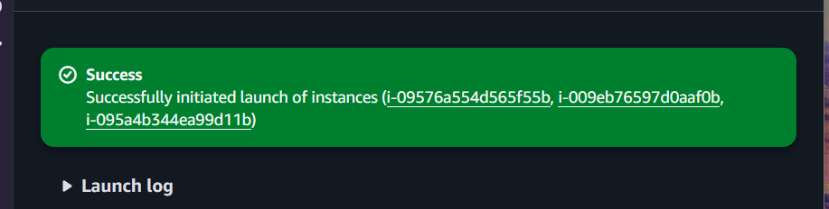
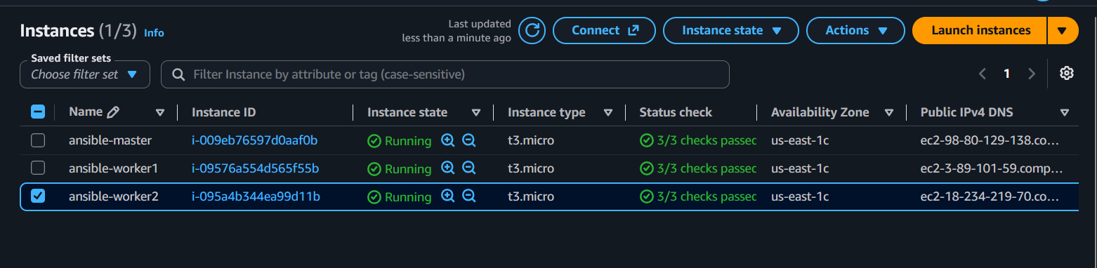

3. Connect to the master
On your Windows computer, open Git Bash. Go to the folder containing your downloaded EC2 private key.
chmod 400 ansible-lab.pem
ssh -i ansible-lab.pem ubuntu@MASTER_PUBLIC_IP
Replace MASTER_PUBLIC_IP with the master's actual public IPv4 address.
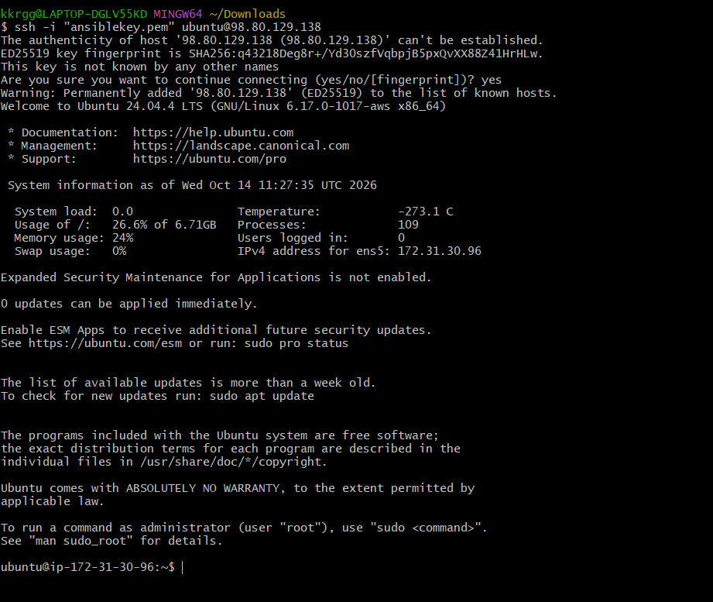

4. Install Ansible on the master
Run these commands on the master instance:
sudo apt update
sudo apt install ansible openssh-client python3 -y
ansible --version
Ansible should display its installed version.
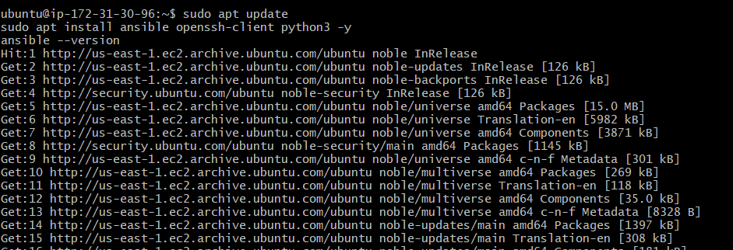
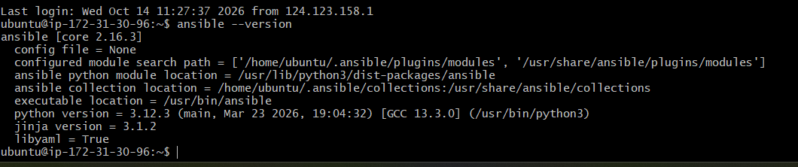

5. Configure SSH access to the workers
For this simple lab, we'll use the same EC2 key pair for the workers. Transfer the private key to the master from your local Git Bash terminal:
scp -i ansible-lab.pem ansible-lab.pem \
ubuntu@MASTER_PUBLIC_IP:/home/ubuntu/ansible-lab.pem
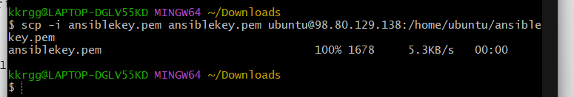
Reconnect to the master if needed, then run:
chmod 400 ~/ansible-lab.pem
Security note: This places a private key on the master. Use a dedicated lab key, restrict SSH access, and remove the key from the master when the lab is finished.
From the master, verify SSH connectivity to each worker using its private IP address:
ssh -i ~/ansible-lab.pem ubuntu@WORKER1_PRIVATE_IP
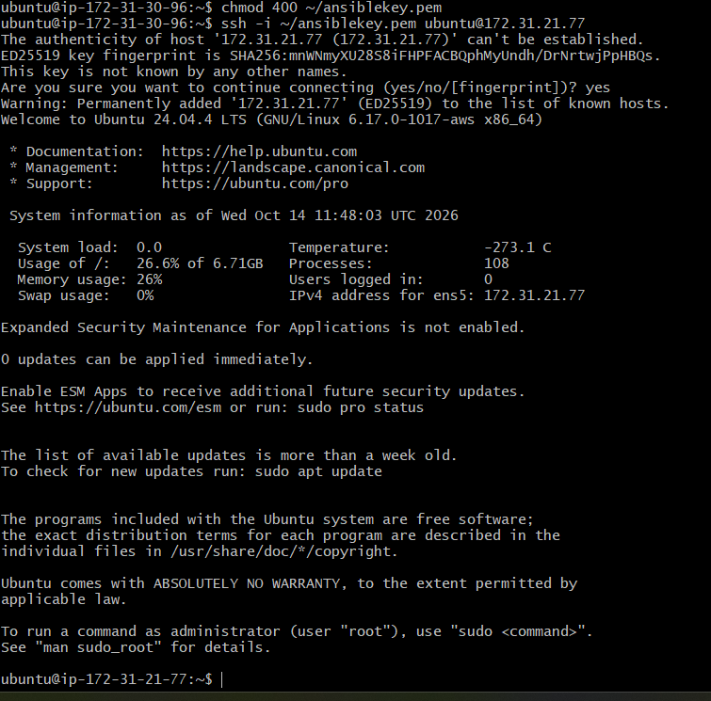
Accept the host fingerprint if it matches the instance you launched. Run exit to return to the master, then repeat for worker 2:
ssh -i ~/ansible-lab.pem ubuntu@WORKER2_PRIVATE_IP
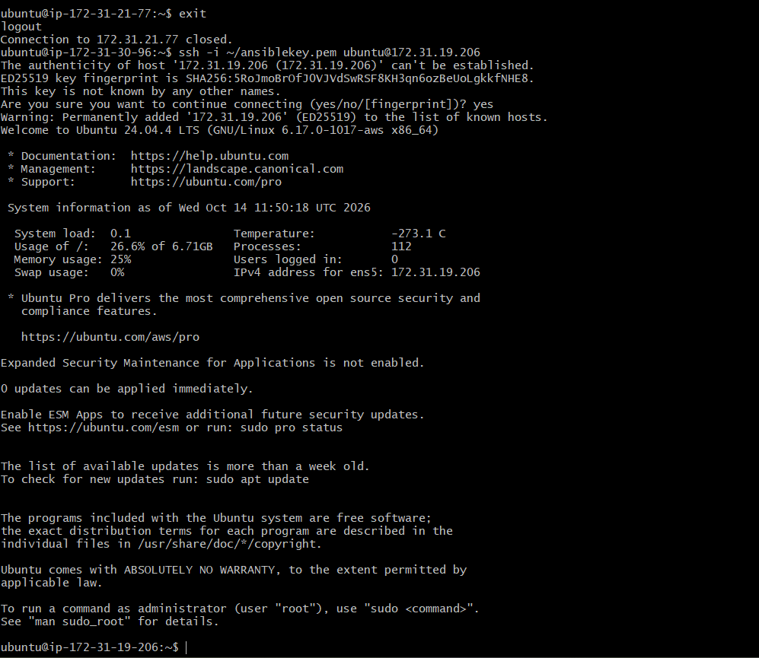
Both connections should work without a password prompt. If not, check the security group, private IPs, and key permissions.

6. Create the Ansible inventory
On the master:
mkdir -p ~/ansible-lab
cd ~/ansible-lab
nano inventory.ini
Add the following, replacing both example addresses with your workers' actual private IPs:
[workers]
worker1 ansible_host=10.0.1.101
worker2 ansible_host=10.0.1.102

[workers:vars]
ansible_user=ubuntu
ansible_ssh_private_key_file=/home/ubuntu/ansible-lab.pem
Save and exit Nano using Ctrl+O, Enter, then Ctrl+X.
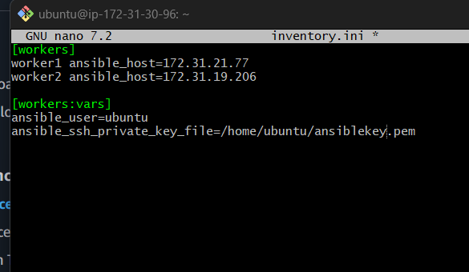

7. Verify both workers with Ansible
Run these commands on the master:
cd ~/ansible-lab

ansible workers -i inventory.ini --list-hosts
Expected output:
hosts (2):
worker1
worker2
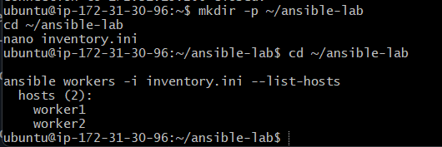
Now verify connectivity:
ansible workers -i inventory.ini -m ping
Expected result:
worker1 | SUCCESS => {
"changed": false,
"ping": "pong"
}
worker2 | SUCCESS => {
"changed": false,
"ping": "pong"
}
The order may vary. Both workers should return "ping": "pong".
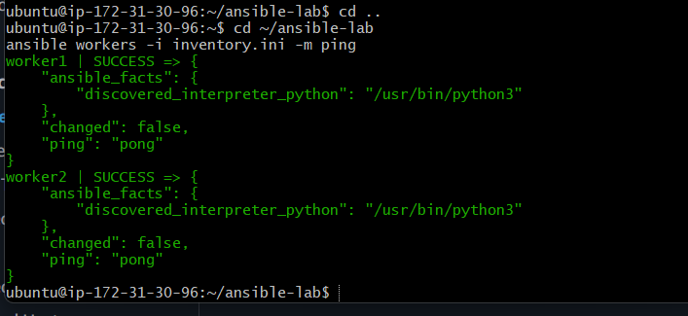

Final architecture
Ansible Master
172.31.30.96
Ansible installed
Worker 1
172.31.21.77
Worker 2
172.31.19.206

Task 2: Execute the adhoc command shared in document

1. Check connectivity between workers
Document command:
ansible all -m ping
use inventory.ini, so run:
ansible all -m ping -i inventory.ini
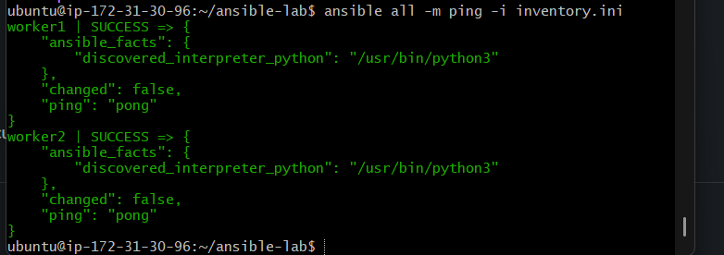

2. Gather facts from worker machines
ansible all -m setup -i inventory.ini
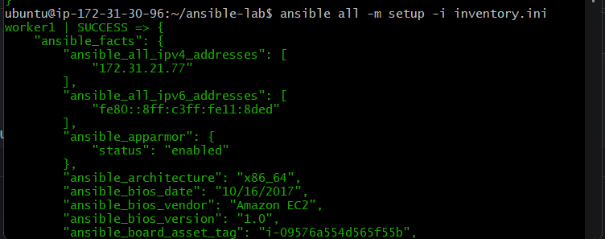

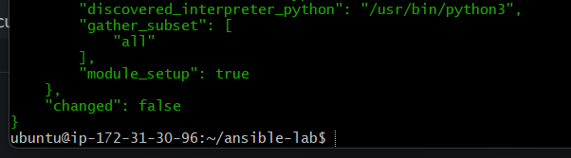

3. Test username and password authentication
Document command:
ansible all -m ping --user=ansadm --ask-pass
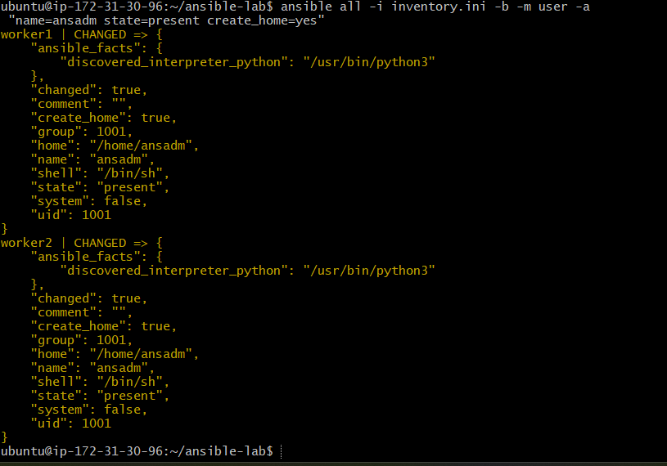

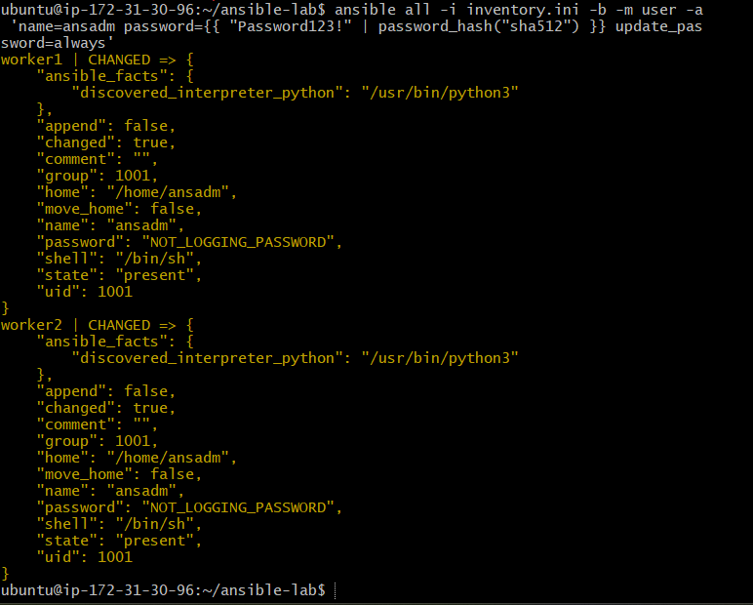
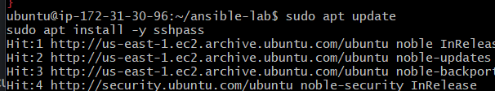

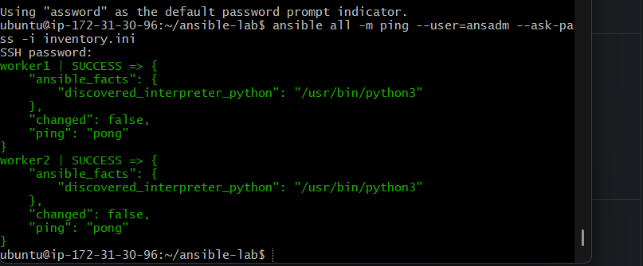
This tests password-based SSH for user ansadm. Your current workers use ubuntu and SSH keys, so run this only if you have configured ansadm and password authentication.

4. Check worker uptime
ansible all -a uptime -i inventory.ini
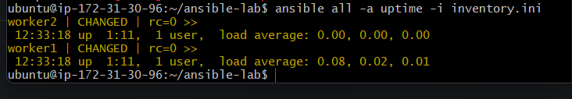

5. Check memory usage
ansible all -a "free -m" -i inventory.ini
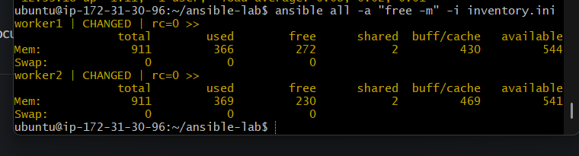

What does it do?
- ansible all — targets both worker nodes.
- -a "free -m" — executes the Linux memory-reporting command.
- -m in free -m means display memory values in megabytes.
- -i inventory.ini — specifies your inventory.

6. Execute a command as root using sudo
Document command:
ansible all -m shell -a "cat /etc/passwd|grep -i ansadm" -s --ask-sudo-pass
The -s and --ask-sudo-pass options are outdated. Use the document's next, equivalent become approach instead:
ansible all -m shell -a "cat /etc/passwd|grep -i ansadm" -b -K -i inventory.ini
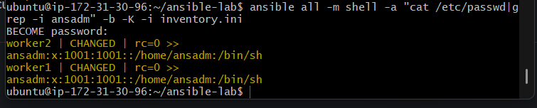
This asks for the sudo password. If your Ubuntu user has passwordless sudo, you can use -b without -K.

What do the options mean?
- -m shell — uses the shell module to execute a shell command.
- -a — specifies the command to run.
- cat /etc/passwd | grep -i ansadm — searches the account database for the ansadm user.
- -b — enables privilege escalation (sudo).
- -K — prompts for the sudo password.
- -i inventory.ini — specifies your inventory file.

7. Execute a command as the ansadm user
ansible all -m file -a "path=/home/ansadm/test state=directory mode=0755" -b --become-user=ansadm -i inventory.ini
This requires the ansadm user to exist on both workers.
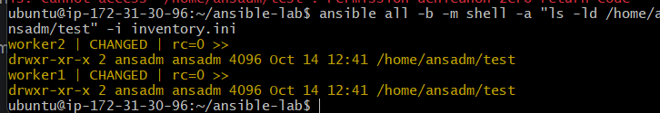

8. Create a Linux user group
Document command:
ansible all -s -m group -a "name=test state=present" -b -K
Use the current syntax:
ansible all -m group -a "name=test state=present" -b -K -i inventory.ini
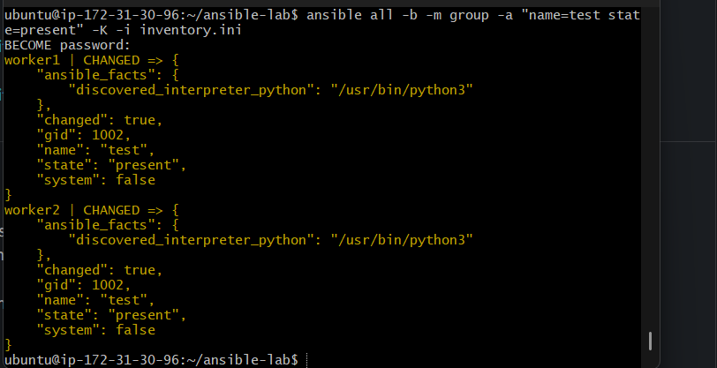

9. Create a file with permission 755
The document specifies /home/asnadm/testfile:
ansible all -m file -a "path=/home/asnadm/testfile state=touch mode=0755" -i inventory.ini
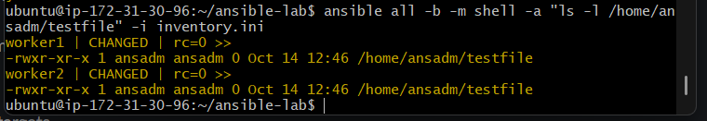

10. Change file ownership
ansible all -m file -a "path=/home/ansadm group=weblogic owner=weblogic" -b -i inventory.ini
This requires the weblogic user and group to exist on both workers.
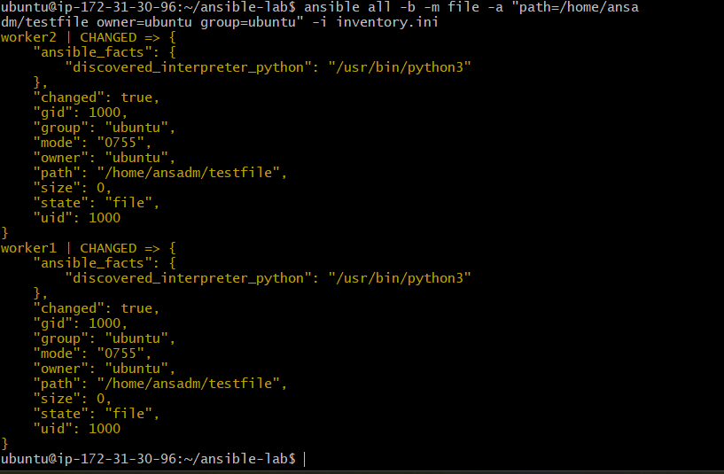

11. Install a package using yum
The document's command is:
ansible all -m yum -a "name=httpd state=installed"
Ubuntu compatibility: Ubuntu uses apt, not yum. To perform the same package-installation exercise on your Ubuntu workers, use:
ansible all -m apt -a "name=apache2 state=present update_cache=yes" -b -i inventory.ini
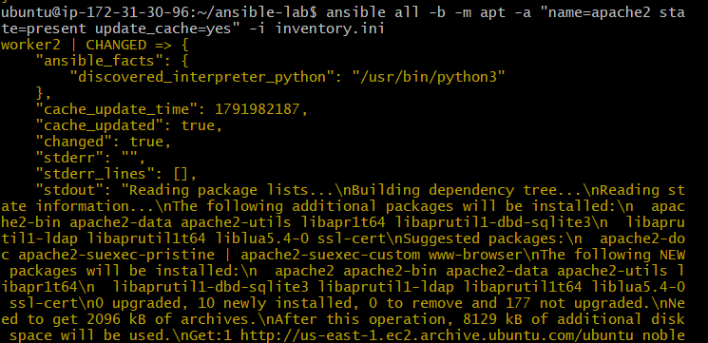

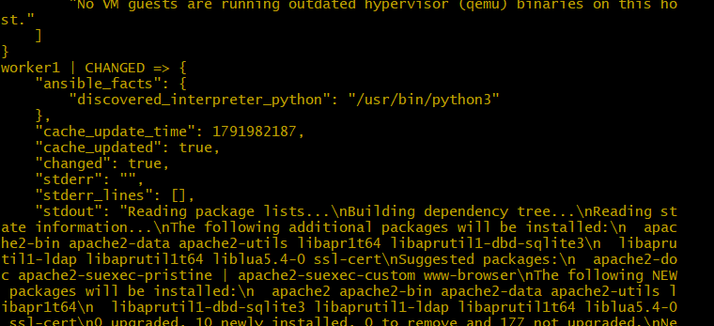

12. Start or stop a service
The document uses the httpd service. For Ubuntu, the corresponding service is apache2.
Start and enable:
ansible all -m service -a "name=apache2 state=started enabled=yes" -b -i inventory.ini
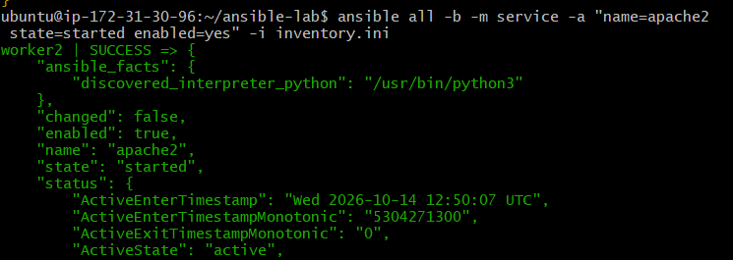

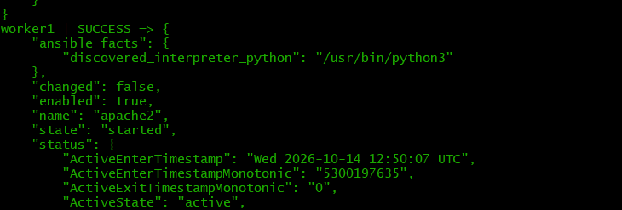

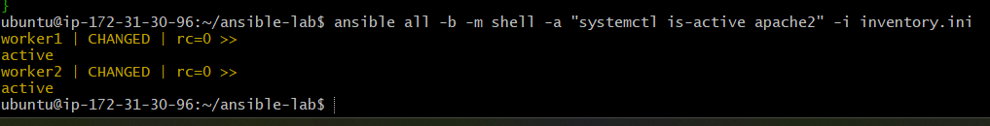
Stop:
ansible all -m service -a "name=apache2 state=stopped" -b -i inventory.ini

